Mt. Everest Brochure Activity
Sophomore English

Objective: Using your knowledge of rhetorical devices and modes of persuasion, create a functional text for a Mt. Everest climbing trip.

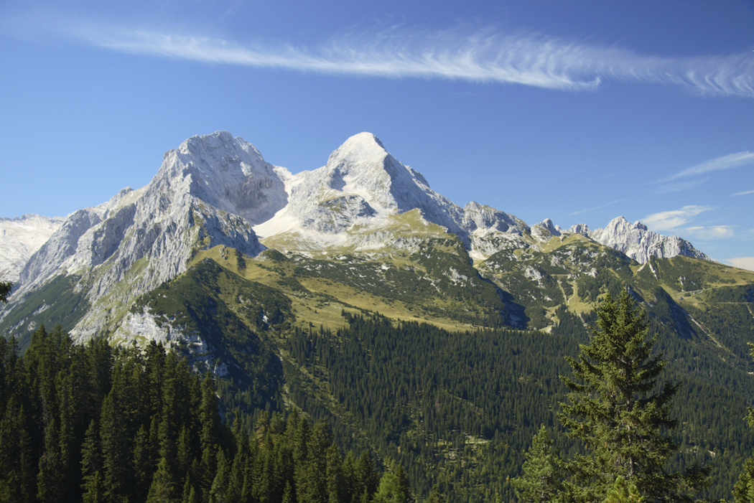
Directions: Persuade vacationers and adventure seekers to visit Mt. Everest through a brochure advertisement. Include any information a traveler might need to know before making the trip. You will use computer sized paper and fold like a brochure. Cover all folds in the brochure with words, pictures, and color.

- Persuasive slogan (5pts.)
- General information: cost, weather conditions, climbing conditions (5pts.)
- General necessities: food, clothing, equipment (5pts.)
- The how’s and why’s to make this trip (5pts.)
- Any other information you find important or intriguing (5pts.)

Be creative and remember that your job is not only to inform the traveler, but to persuade.
Beef up your word choice and make it interesting!

Activity worth 25 points total

Mt. Everest Brochure Activity
Sophomore English

Objective: Using your knowledge of rhetorical devices and modes of persuasion, create a functional text for a Mt. Everest climbing trip.

Directions: Persuade vacationers and adventure seekers to visit Mt. Everest through a brochure advertisement. Include any information a traveler might need to know before making the trip. You will use computer sized paper and fold like a brochure. Cover all folds in the brochure with words, pictures, and color.

- Persuasive slogan
- General information: cost, weather conditions, climbing conditions
- General necessities: food, clothing, equipment
- The how’s and why’s to make this trip
- Any other information you find important or intriguing

Be creative and remember that your job is not only to inform the traveler, but to persuade.
Beef up your word choice and make it interesting!

Activity worth 25 points total

